IoT Based Vehicle Accident And Tracking System Using Raspberry pi and ESP32

## PROJECT REPORT

***Submittedby***

# NAME OF THE CANDIDATE(S)

Bhartendu Raj(21BEC1186) Khushboo (21BEC1198) GoodLuck E.N. (21BEC1100) Raj(21BEC1177)

***in partial fulfillment for the award of the degree of***

# BACHELOR OF ENGINEERING

**IN**

## ELECTRONICS AND COMMUNICATION ENGINEERING



**Chandigarh University**

November 2024



# BONAFIDE CERTIFICATE

Certified that this project report **“ IoT Based Vehicle Accident And Tracking System Using Raspberry pi and ESP32 ”**is the bonafide work of “ **Raj , Khushboo** , **Bhartendu Raj , Goodluck Emilian Nuhu ”** who carried out the project work under my/our supervision.

**SIGNATURE**

Dr. Rishabh Dev Shukla

**HEAD OF THE DEPARTMENT**

Electronics and Communication Engineering

**SIGNATURE**

Dr. Gaurav Aggarwal

**SUPERVISOR**

Electronics and Communication Engineering

Submitted for the project viva-voce examination held on 14th November 2024

**INTERNAL EXAMINER EXTERNAL EXAMINER**

**ACKNOWLEDGEMENT**

**Chandigarh University**

November 2024

We would like to express our gratitude towards Dr. Gaurav Aggarwal and our honorable HOD Dr. Rishabh Dev Shukla, of Chandigarh University for their support in accomplishment of our project on ― **IoT Based Vehicle Accident And Tracking System Using Raspberry pi and ESP32**

I would like to express my profound gratitude to my fellow group members. Their unwavering support and exceptional coordination have been instrumental in our successful completion of this project. Without their invaluable contributions, we would not have been able to achieve the desired outcome.

# TABLE OF CONTENTS

List of Figures vi

List of Tables vii

Abstract… viii

CHAPTER 1. INTRODUCTION

* 1. Identification of Relevant Contemporary issue 1
  2. Identification of Problem 2
  3. Identification of Tasks 3
  4. Timeline 6
  5. Organization of the Report 6

CHAPTER 2. LITERATURE REVIEW/BACKGROUND STUDY

* 1. Timeline of the reported problem 10
  2. Existing solutions 11
  3. Bibliometric analysis 12
  4. Review Summary 18
  5. Problem Definition 18
  6. Goals/Objectives 25

CHAPTER 3. DESIGN FLOW/PROCESS .......................................................

* 1. Evaluation & Selection of Specifications/Features 27
  2. Design Constraints 31
  3. Analysis of Features and finalization subject to constraints …………………/… 36
  4. Design Flow 38
  5. Design selection 42
  6. Implementation plan/methodology 43

CHAPTER 4. RESULTS ANALYSIS AND VALIDATION ..........................

4.1. Implementation of solution 46

CHAPTER 5. CONCLUSION AND FUTURE WORK ..................................

* 1. Conclusion 49
  2. Future work 50

## REFERENCES 52

**APPENDIX 53**

1. Plagiarism Report
2. Design Checklist

# List of Figures

### Figure 1.4 6

### Figure 3.5 42

### Figure 3.6.1 43

### Figure 3.6.2 44

### Figure 4.1 46

### Figure 4.2 47

### Figure 4.3 48

### Figure 4.4 48

# List of Tables

**Table 2.3 12**

# ABSTRACT

The necessity for effective and quick response systems to reduce property and fatality losses is highlighted by the rising frequency of traffic accidents. Timely intervention is hampered by the lack of real-time response capabilities in traditional accident detection and tracking systems. In order to improve accident response, enable precise car monitoring, and give emergency services real-time data, this project suggests an Internet of Things (IoT)-based vehicle accident and tracking system that makes use of the ESP32 microcontroller. The system has a gyroscope to identify abrupt changes in motion that could be signs of an accident, an accelerometer, and a GPS module to track the location of the car. When an accident happens, the ESP32 microcontroller automatically triggers the alarm system after receiving data from the sensors and processing it to see if the impact surpasses a certain threshold. When an accident is detected, the GPS module records the location coordinates, which the ESP32 then sends to a distant server or emergency contacts via GSM or Wi-Fi. By ensuring that emergency services are notified instantly, this real-time alerting system minimises the time it takes for help to arrive. Additionally, by integrating with a web interface or mobile application, the system enables users or responders to access location data, monitor vehicle status, and receive warnings in an easy-to-use format.

Through the use of IoT technologies and the inexpensive, low-power ESP32 microcontroller, this system offers a practical way to track cars and identify collisions. The system can be widely adopted because to its affordability and portability, especially in areas with inadequate infrastructure for accident response and traffic monitoring. In addition to speeding up response times and saving lives, this Internet of Things-based system makes it possible to gather data that can support policy and research on road safety

# CHAPTER 1. INTRODUCTION

## Client Identification/Need Identification/Identification of relevant Contemporary issue

* + 1. **Client Identification**: An IoT-Based Vehicle Accident Detection and Tracking System's main customers are as follows:

Car manufacturers are interested in improving vehicle safety by integrating IoT-enabled accident detection capabilities.

Effective accident management is essential for transportation and logistics companies in order to guarantee timely reactions and save damages.

**Emergency Response Services:** Enhance response speeds by utilising real-time accident tracking.

**Insurance Companies:** Assess claims and improve services by using accident data. Owners of individual vehicles should look for improved safety features to safeguard themselves and their families.

### Identification of Needs:

Worldwide, accidents are a major safety and financial concern since they result in fatalities, serious injuries, and high costs. Vehicle accidents can save lives and reduce damage if they are detected and responded to quickly. Delays in reporting accidents and identifying the precise location of the incident, however, frequently prevent emergency personnel from responding promptly.

### This system seeks to meet this requirement by:

**Real-time Accident Detection:** This technique uses sensors and microcontrollers to identify accidents and notify the appropriate parties right away.

**Accurate Location Tracking:** Giving family members and emergency personnel the ability to use GPS to locate the accident site.

**Automated Emergency Notification:** Notifying emergency contacts and services automatically to enable prompt action.

* + 1. **Finding a Relevant Current Issue:** The growing incidence of car accidents worldwide and the difficulties in responding to them are urgent current issues. According to the World Health Organisation (WHO), traffic accidents claim the lives of about 1.3 million people annually.

Following an accident, prompt aid can significantly lower the number of fatalities and the severity of injuries.

This project develops a dependable accident detection and tracking system by utilising the ESP32 microcontroller and Internet of Things technology. This system, which uses GPS tracking and internet connectivity, solves the problem of delayed accident response by providing a quicker, automatic way to alert family members and emergency agencies, guaranteeing accident victims receive assistance more quickly.

## Identification of Problem

One of the leading causes of injuries and fatalities worldwide is vehicular accidents. Accidents are frequently not detected and reported in a timely manner, which can cause delays in emergency response, raise the risk of serious injuries, and occasionally lead to fatalities. This delay frequently occurs because:

* + 1. **Accidents Go Unnoticed:** Accidents that take place in isolated or sparsely inhabited areas could go unreported for a while. Accident victims could not get the help they need in time if there is no mechanism to notify emergency personnel right away.
    2. **Absence of Accurate Location Information:** It can be difficult to provide the exact location of an accident, even if it is reported, particularly if the driver or passengers are confused or unable to communicate. Emergency services may take longer to get at the scene of the collision as a result.
    3. **Manual Reporting Is Unreliable and Slow:** Manual accident reporting is frequently unreliable because victims or onlookers may not have instant access to communication equipment or may be incapacitated.
    4. **Delayed Response Times:** It's crucial to consider how long it takes for emergency personnel to be alerted and show up at the scene of an accident. The likelihood of survival and successful treatment can be decreased if important time is lost in the absence of an automated, prompt notification system.
    5. **Problems in Urban and Rural regions:** In urban regions with heavy traffic, other cars may block accidents, causing congestion and additional dangers. In contrast, it may be challenging to notify emergency personnel of an accident in rural or isolated areas due to a lack of cellular

network coverage.

## Identification of Tasks

The following is a breakdown of the main tasks involved in developing the IoT-Based Vehicle Accident Detection and Tracking System using ESP32, which are arranged to cover every stage of the project, from planning and design to implementation and testing:

### Project Planning and Requirement Analysis

**Identify Project Requirements:** Specify the necessary hardware, such as the ESP32 microcontroller, GPS module, accelerometer, gyroscope, power supply, and other required sensors. Define the project's specific requirements, such as sensor specifications, GPS accuracy, connectivity requirements, and power constraints.

**Ascertain the Software Needs:** Determine the software tools required, including libraries for IoT and GPS functionality and programming languages (e.g., Arduino IDE, MicroPython).

**Describe the protocols used in communication:** Choose and create the communication protocols (such as HTTP and MQTT) that will be used to send data to central servers or emergency contacts.

### Architecture and Design of the System

**Create Architecture of the System:** Create a system blueprint that describes the interactions between the ESP32, sensors, and GPS module.

**Create circuit schematics:** To incorporate sensors, a GPS module, an ESP32, and power sources, make wiring diagrams.

**Create a Data Flow:** Specify the data flow from sensors to the ESP32 and from the ESP32 to the emergency contacts or server.

**Determine the Emergency Alert System:** Select the platforms that will receive the alerts and the method of notification delivery (such as SMS, email, or app notifications).

### Component Integration and Hardware Setup

**Integrate Sensors and GPS Module:** Connect accelerometers, gyroscopes, GPS module, and any additional sensors to the ESP32.

**Calibrate Sensors:** Test and calibrate each sensor to ensure accurate accident detection and data collection.

**Configure ESP32:** Program the ESP32 to handle inputs from sensors, GPS, and communication modules (Wi-Fi or Bluetooth).

**Power Supply and Battery Management:** Set up a reliable power source for continuous monitoring and possibly implement a low-power mode to conserve energy.

### Software Development

**Develop Accident Detection Algorithm:** Create algorithms that can detect sudden impacts or changes in speed/acceleration that indicate an accident.

**Implement GPS Tracking Functionality:** Program the GPS module to accurately track and transmit the vehicle’s location in real-time.

**Configure IoT Communication Protocol:** Implement communication protocols like MQTT or HTTP for sending real-time alerts to a central server or designated contacts.

**Develop Emergency Alert System:** Program the system to send automated alerts (SMS, emails, or app notifications) when an accident is detected.

**Develop User Interface (if required):** If the system includes a mobile or web application, design a simple interface to receive alerts and display location data.

### Testing and Validation

**Unit Testing:** Test each individual component (e.g., sensors, GPS module, ESP32) for correct functionality.

**Integration Testing:** Ensure the sensors, GPS, and ESP32 work together seamlessly.

**Accident Detection Testing**: Simulate different levels of impacts to test the accident detection algorithm's accuracy and response time.

**GPS Accuracy Testing:** Test the GPS module’s accuracy in different environments (urban, rural) to ensure it provides reliable location data.

**Connectivity Testing:** Test the device’s connectivity over Wi-Fi or Bluetooth and ensure that notifications are sent promptly in case of an accident.

**Notification and Alert Testing:** Verify that emergency contacts receive alerts promptly and consistently.

### Field Testing and Deployment

**Prototype Deployment:** To evaluate performance under actual driving circumstances, install the prototype in a car.

**Testing in the Field under Various Conditions:** To assess dependability, test the system's operation in a range of settings, such as fast speeds, rugged terrain, and remote locations.

**Analyse System Response Time:** Calculate how long it takes to notice an issue and send and receive alerts.

**Get User Input:** To find areas for improvement, get input from test users (drivers, emergency contacts).

### Analysis and Optimisation of Data

**Analyse Test Data:** To enhance GPS accuracy and optimise accident detection algorithms, analyse test data.

**Enhance System Efficiency:** To increase accuracy, reduce power consumption, and speed up response times, modify hardware components and write better code.

**Debugging and Problem Solving:** Find and address any hardware or software problems that affect system performance.

### Final Report and Documentation

**Create Technical Documentation:** Record the codebase, hardware configuration, system architecture, and troubleshooting procedures.

**Write User Manuals:** Write a guide that provides end users with installation, configuration, and usage instructions.

**Compile Test Results and Analysis:** The final project report should contain comprehensive testing data, analysis, and insights.

**Create Maintenance Guidelines:** Give instructions for system upkeep, such as hardware inspections and software upgrades.

### Final Installation and Maintenance

**Set Up the System for Practical Use**: Install the equipment in client cars or cars that are utilised for on-the-road surveillance.

**Establish Maintenance Procedures:** Put procedures in place for system updates, monitoring, and troubleshooting.

**Give instruction (if necessary):** Teach the appropriate staff members or users how to utilise and keep an eye on the system.

**Create an input Loop:** To keep the system getting better, put in place a way for users to provide regular input.

## Timeline

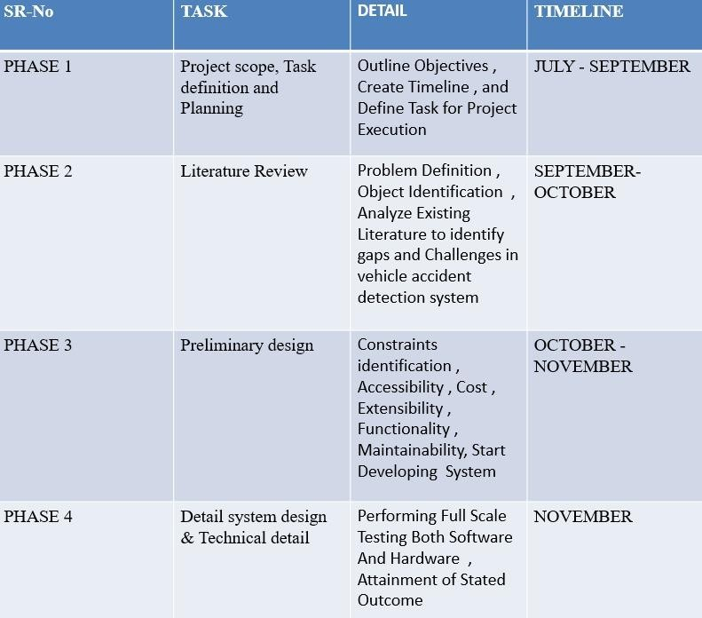

**Fig 1.4 Gantt Chart**

## Organization of the Report

### CHAPTER 1. INTRODUCTION

**Abstract** : Give a succinct overview of the project that covers its goals, methods, main discoveries, and conclusions. A high-level summary of the project's objectives and results should be provided to readers in this section.

**Background of the Project:** Talk about the background of auto accidents and stress the importance of rapid reaction systems. Emphasise how crucial location tracking and accident detection are.

**Statement of the Problem:** Clearly state the issue that the project is trying to resolve, including the problems with the way that accidents are currently reported and tracked.

**Goals:** Describe the project's primary goals, including creating an automated system for detecting accidents and guaranteeing precise position tracking.

**Project Scope:** Specify the project's parameters, its scope, and any restrictions.

### CHAPTER 2. LITERATURE REVIEW/BACKGROUND STUDY

**Review of Existing Solutions:** Examine the advantages and disadvantages of the most recent accident tracking and detection technology.

**IoT in Transportation:** Talk about how the automobile industry has recently advanced IoT applications, especially in safety systems.

**Relevance of ESP32:** Give a summary of the features of ESP32 and how well suited it is for Internet of Things applications in vehicle safety.

**Sensors for Accident Detection:** Provide an overview of studies on sensors such as gyroscopes and accelerometers and how they can be used to identify abrupt motion changes and impacts.

### CHAPTER 3. DESIGN FLOW/PROCESS

**System Design and Architecture**

* **System Overview**: Provide a high-level description of the system and its components.
* **Hardware Components**: Detail the hardware used, including the ESP32 microcontroller, GPS module, accelerometer, gyroscope, and power supply.
* **Software Architecture**: Explain the software structure, including the accident detection algorithm, GPS tracking, and communication protocol.
* **Communication Protocols**: Describe the protocols (e.g., MQTT, HTTP) selected for sending notifications and why they were chosen.
* **Data Flow Diagram**: Include diagrams that illustrate the data flow within the system from sensor input to the transmission of alerts.

### Implementation of the System

**Hardware Setup:** Explain how the ESP32 is physically configured, wired, and connected to sensors and GPS.

**Sensor Integration:** Describe how the GPS module and sensors (gyroscope, accelerometer) are calibrated and tested.

**ESP32 Programming:** Describe how to set up the ESP32 to process sensor data and send notifications.

**Accident detection algorithm**: it uses sensor data to identify accidents. Describe the process for automatically notifying specified contacts with GPS coordinates in the event of an emergency.

**Power Management:** Describe how power is controlled to maintain system functionality and energy efficiency.

### CHAPTER 4. RESULTS ANALYSIS AND VALIDATION

**Results and Discussions**

**System Performance:** Provide an overview of the system's performance in terms of GPS tracking dependability, notification speed, and accident detection accuracy.

**Comparison with Current Solutions:** Examine how well the developed system performs in comparison to other current solutions.

**Challenges Faced:** Talk about any difficulties that arose during the development and testing process, such as problems with power management, sensor calibration, or connectivity.

**Limitations:** Be aware of any restrictions the system may have, such as its reliance on GPS availability or possible problems in places with poor network coverage**.**

### CHAPTER 5. CONCLUSION AND FUTURE WORK

**In conclusion**

**Project Summary:** Summarise the primary goals, methodology, and results of the project. Highlight the project's major accomplishments, such as the effective creation and testing of an accident tracking and detection system.

**Future Work:** Make recommendations for features that could improve the system or areas for improvement, like stronger network connectivity or integration with car diagnostic data. **Practical Implications:** Talk about the system's advantages for emergency response and automobile safety as well as its possible real-world effects.

# CHAPTER 2.

**LITERATURE REVIEW/BACKGROUND STUDY**

## Timeline of the reported problem

For many years, delayed accident reporting and detection has been acknowledged as a major road safety issue on a global scale. Faster detection and emergency response could save many lives, as vehicle accidents are a major cause of injuries and fatalities globally. A synopsis of the problem's identification process and supporting documentation regarding the necessity of automated accident detection and tracking systems can be found below.

### Global Identification of the Problem

**World Health Organization (WHO) Reports:**Road traffic injuries are a serious public health concern, according to World Health Organisation (WHO) reports. According to current studies, there are over 1.3 million road accident-related deaths annually, which the WHO emphasises in its Global Status Report on Road Safety (2009, 2013, 2018). According to these data, minimising fatalities and severe injuries requires prompt emergency action**.**

**United Nations (UN) Road Safety Goals:** In 2015, the UN established a goal to cut the number of road traffic accident deaths and injuries worldwide in half by 2030 as part of the Sustainable Development Goals (SDGs). Faster accident identification, reporting, and reaction are crucial components of lowering traffic-related fatalities, as this rule emphasises.

**The United States' National Highway Traffic Safety Administration (NHTSA):** Delays in emergency response following an accident can have a major influence on the chances of survival for everyone affected, according to the NHTSA. According to their statistics, the "golden hour," or the first hour following an accident, is crucial for saving lives, and prompt accident detection can greatly speed up response times.

### Documentary Evidence of Events

**Trauma and Acute Care Surgery Journal:** Response time is crucial for saving lives after an accident, according to studies published in this journal. Response times longer than 30 minutes have been shown to significantly raise accident victim fatality rates. According to these research, in order to speed up reaction times, a system that can automatically identify and report incidents is required.

**Academic Research on Accident Detection Systems:** The limitations of the present accident reporting methods, such as manual reporting by witnesses or victims, which can cause delays, have been the subject of numerous research publications published in IEEE and other academic journals. For instance, research published in IEEE Transactions on Intelligent Transportation Systems highlights the shortcomings of conventional reporting systems and promotes IoT-based solutions that have the ability to communicate exact position data and detect accidents on their own.

**Insurance Claims and Delays:** Due to a lack of automated detection, insurance firms have documented instances in which accidents remained unreported for prolonged periods of time. The processing of claims becomes complicated as a result of these reporting delays, and more significantly, medical help is delayed. Leading insurance companies' reports highlight how instant accident identification can expedite claim procedures and improve the accuracy of investigations.

**Government Reports and Statistics:** A number of countries give information on accident deaths and emphasise the need for better post-event response, such as the European Union's (EU) Road Safety Report and India's Ministry of Road Transport and Highways' yearly reports. For example, the EU's "Vision Zero" study highlights that cutting emergency response times with sophisticated accident detection systems is one method to reach the goal of zero road fatalities.

### Major Incidents Highlighting the Need for Improved Accident Detection

**Remote Area Accidents:** Several well-known incidents have demonstrated how mishaps in isolated or sparsely populated regions can go unnoticed for hours, resulting in preventable deaths. Reports from nations like the U.S. and Australia, for instance, highlight the necessity of automated accident detection systems that can operate even in isolated locations with spotty cellular service.

**Highway and Nighttime Accidents:** According to statistics, accidents that happen on highways or at night frequently take longer to be detected since fewer people are likely to witness them. Automated accident detection is essential since nighttime accident fatalities are disproportionately high due to lengthier reaction times, according to data from national transportation departments.

**Motorcycle Accidents:** Studies conducted in nations with large motorbike populations, such Vietnam, Thailand, and India, reveal that accidents involving motorcycles frequently go unreported, particularly in less-traveled areas. An automated method could greatly enhance emergency response for similar occurrences, according to studies.

## Existing solutions

### Manual Accident Reporting Systems:

In the past, drivers or onlookers would call emergency services to report occurrences, relying largely on manual communications.

### Emergency Call (eCall) Systems in Vehicles:

An effort called eCall makes automatic calls to emergency agencies in the event of an accident. The eCall systems seen in many new cars in North America and Europe trigger when the airbag deploys.

### Smartphone-Based Accident Detection Applications:

Applications for smartphones use the GPS and accelerometer built into the device to identify collisions and issue alarms. If users believe they are in danger, several apps also let them manually set off alarms.

### Black Box Recorders with GPS:

These devices capture information like position, speed, and braking patterns, just like aeroplane black boxes do. Some have real-time data provided by GPS integration, which can be useful for accident reconstruction.

## Bibliometric analysis

**TABLE 2.3**

|  |  |  |  |  |
| --- | --- | --- | --- | --- |
| **Title** | **Authors** | **Journal/Conference** | **Finding** | **Gaps** |
| Real-Time Vehicle Accident Detection and Notification System Using IoT | Sharma, P., Gupta, A. | International Journal of Advanced Research in Computer Science, 2020 | Proposed an IoT- based accident detection system using GPS and GSM for alerting emergency services.  Incorporated alcohol sensors to detect intoxication. | Did not include anti-sleep alarms or smoke detection; lacks evaluation on real-time responsiveness in varying environments. |
| Smart Vehicle Monitoring System for Accident Prevention and Detection Using IoT | Kumar, V., Rani, S. | IEEE Sensors Conference, 2021 | Developed a comprehensive accident prevention system that uses GPS, GSM, and  alcohol detection sensors. | Lacks anti-sleep functionality and smoke detection; limited testing in harsh conditions and extreme weather. |
| IoT-Based Driver Health Monitoring for Accident Prevention | Ahmed, M., and Lee, J. | Journal of Internet Technology, 2022 | Focused on a health monitoring system for detecting alcohol and drowsiness, which could prevent accidents by notifying the driver. | No provision for accident detection or smoke detection system; limited integration with vehicle data. |

|  |  |  |  |  |
| --- | --- | --- | --- | --- |
| Detection of Driver Drowsiness Using IoT and Cloud Computing | Bansal, R., Srivastava, N | Procedia Computer Science, 2021 | Implemented a driver drowsiness detection system based on EEG sensors and cloud data storage for analysis and alarm notifications. | Does not include alcohol or smoke detection; requires improvement in real-time alert reliability. |
| Vehicle Accident Detection and Alcohol Detection System Using IoT | Singh, T., Kaur, M | International Journal of Electronics and Communication, 2020 | Combined alcohol detection with accident detection, alerting emergency contacts if an intoxicated driver is detected. | Anti-sleep and smoke detection features are absent; lacks comprehensive testing on complex driving patterns. |
| IoT-Based Driver Alert System with Anti-Sleep and Alcohol Detection | Ali, Z., Chen, Y. | IEEE Internet of Things Journal, 2022 | Developed an anti-sleep system with alcohol detection, notifying the driver and emergency contacts if thresholds are  crossed. | No smoke detection integration; requires further testing for real- time performance in varying terrains. |

|  |  |  |  |  |
| --- | --- | --- | --- | --- |
| Intelligent Vehicle Accident Detection System Using IoT and ML Algorithms | Park, H., and Kim, J. | IEEE Access, 2023 | Applied machine learning for real- time accident prediction using IoT sensors.  Alcohol detection is included as a preventive measure. | Absence of smoke detection and anti-sleep functionalities; testing limited to controlled environments |
| Anti-Sleep Driver Assistance System Using IoT and EEG Sensors | Chawla, A., Goel, R | Journal of Computational and Cognitive Engineering, 2020 | Designed an IoT- based anti-sleep alarm using EEG for driver drowsiness detection and alert generation. | No alcohol or smoke detection; scalability and cost- effectiveness require further analysis. |
| Multi-Sensor- Based Accident Detection System for Smart Vehicles | Brown, L., Zhang, W | IEEE Transactions on Intelligent Transportation Systems, 2023 | Combined accelerometers and GPS sensors for accurate accident detection and notification | Anti-sleep and smoke detection features are missing; requires validation in practical, complex driving environments |

|  |  |  |  |  |
| --- | --- | --- | --- | --- |
| IoT-Enabled Vehicle Safety System Integrating Alcohol Detection and Accident Alerting | Patel, S., and Mehta, P. | Journal of Computational and Cognitive Engineering, 2020 | Focused on integrating alcohol detection with accident alerting features using GSM modules. | Anti-sleep and smoke detection not implemented; lacks advanced functionality in real-time monitoring and AI-driven predictions |
| IoT-Based Safety Monitoring System with Alcohol and Smoke Detection in Vehicles | Wang, X., Liu, F. | Journal of Intelligent Transportation Systems, 2022 | Implemented both alcohol and smoke detection sensors, notifying contacts if either threshold is reached | Anti-sleep functionality was not integrated; limited testing under emergency response times and reliability conditions. |
| Real-Time Driver Monitoring and Accident Prevention Using IoT Sensors | Nguyen, T., Singh, A | Advances in Intelligent Systems and Computing, 2019 | Designed a real- time monitoring system with accident prevention, including basic alcohol detection functionality. | Did not integrate anti-sleep or smoke detection; minimal exploration of system resilience under diverse environmental conditions. |

### Manual Accident Reporting Systems:

The necessity for automated accident detection and reporting systems is highlighted by the drawbacks of manual reporting. By doing away with the need for human involvement, automated methods provide precise and timely accident detection. IoT-based systems can overcome these obstacles by utilising sensors, GPS tracking, and communication modules to provide faster and more accurate accident detection—especially in situations where every second matters.

### Emergency Call (eCall) Systems in Vehicles:

IoT-based accident detection and tracking systems that use microcontrollers like ESP32 provide comparable capability at a lower cost and with greater flexibility, even if eCall has significantly enhanced emergency response in contemporary automobiles. By employing different communication protocols, these systems may be able to get around some of eCall's drawbacks, including network dependence, and be modified for older cars. In areas where older cars and financial constraints are common, an IoT-based strategy enables wider adoption, extending the safety advantages to a larger population.

### Smartphone-Based Accident Detection Applications:

Although accident detection apps for smartphones are popular and practical, their drawbacks highlight the necessity of specialised IoT-based systems, such as those that make use of the ESP32 microcontroller. IoT solutions can offer specialised hardware made especially for accident detection, guaranteeing increased accuracy and dependability independent of network availability or smartphone conditions. Furthermore, because IoT-based devices are usually built into the car itself, they are less likely to be lost or damaged in an accident, offering a more reliable way to improve safety and emergency response.

### Black Box Recorders with GPS:

Although black boxes offer useful information for accident analysis, their influence on emergency response times is limited by their inability to communicate in real time or send out instant alerts. These restrictions are addressed by IoT-based accident monitoring systems that use gadgets like the ESP32 microcontroller to provide GPS tracking, automatic notifications, and real-time accident detection. These devices are a great addition to or substitute for black box recorders since they may instantaneously alert emergency contacts, enabling a quicker reaction

in dire circumstances.

## Review Summary

### Manual Accident Reporting Systems:

This approach takes a lot of time and depends on witnesses, which could cause delays, particularly in isolated locations or if the victim is unable to contact for assistance.

### Emergency Call (eCall) Systems in Vehicles:

The majority of contemporary cars come equipped with eCall systems, which can be expensive. Due to their frequent integration into luxury vehicles, they are not widely available. Furthermore, older or less expensive cars might not have access to these technologies.

### Smartphone-Based Accident Detection Applications:

Smartphone-based solutions rely on the user's phone being charged, functional, and within easy reach in the event of an accident. These options are unreliable since phones are readily broken or lost in catastrophic accidents.

### Black Box Recorders with GPS:

Black box recorders usually require post-accident recovery for analysis and lack real-time communication capabilities. They are helpful for accident investigations, but their ability to speed up reaction times is limited because they do not instantly send out emergency notifications.

## Problem Definition

### Manual Accident Reporting Systems:

In manual accident reporting systems, witnesses or accident victims record a collision or accident by manually contacting emergency personnel. This approach, which mostly depends on human

engagement, has historically been the most popular way to start emergency responses. Here's a closer look at the functions, uses, and drawbacks of manual reporting systems that have prompted the hunt for more automated alternatives.

### The Operation of Manual Accident Reporting

**Victim or Witness Action:** In the event of an accident, the injured motorist, passenger, or bystander must assess the extent of the damage and choose to contact emergency services (e.g., 911 in the United States, 112 in the European Union).

**Location and Information Sharing:** Usually, the caller is asked for particular information, like the location of the accident, the number of individuals involved, and the victims' conditions. **Emergency Dispatch:** After receiving the call, emergency dispatchers evaluate the details and send the proper first responders to the scene of the accident, such as firefighters, police, and paramedics.

**Potential Follow-Up Calls:** Depending on bystanders' availability, more witness calls could yield more information.

**The drawbacks of manual accident reporting systems include response time delays.** Manual reporting frequently takes longer, particularly when the accident happens in a remote location with no witnesses or when the victims are disabled.

If no one is there or able to call quickly, response times might be significantly compromised, which lowers the likelihood of survival in dire circumstances.

### Reliance on Observers:

For manual reporting to be effective, someone must see the accident and act. Accidents may be unreported for long periods of time in low-traffic or nocturnal locations, which could result in dangerous delays in emergency aid.

### Dependency on the availability of the network:

For manual reporting to be effective, someone must see the accident and act. Accidents may be unreported for long periods of time in low-traffic or nocturnal locations, which could result in

dangerous delays in emergency aid.

### Dependency on the availability of the network:

A steady cellular network connection is necessary for manual reporting. The reporting process may be further delayed if people are unable to make calls in places with inadequate or nonexistent network coverage.

### Miscommunication Risk:

Issues with communication between the dispatcher and the caller may result in inaccurate situational or geographical facts, which could delay down the response or send insufficient resources to the scene.

### Restricted Ability to Track Location:

In contrast to GPS-enabled devices, manual reporting depends on people providing precise position information. Emergency response attempts may be complicated by callers' inability to provide accurate information in stressful situations or in unfamiliar locations.

### Emergency Call (eCall) Systems in Vehicles:

A safety measure called the Emergency Call (eCall) system was created to automatically notify emergency services in the case of a vehicle collision. In order to alert responders and provide crucial information that enables a quicker and more focused reaction, the system integrates sensors, GPS, and communication technology. In the EU, this system is required for new automobiles, and it has also been implemented in other areas.

### The Operation of eCall Systems

**Automatic Activation on Impact:** Sensors within the car, such as those that detect airbag deployment or a quick deceleration, usually trigger eCall, signalling a serious collision.

### GPS Positioning and Data Transfer:

In addition to other vital information like the type of vehicle, the time of the occurrence, and the direction of travel, the system employs GPS to pinpoint the precise location of the car after it is turned on.

### Communication in Two Ways:

Additionally, eCall creates a speech channel between emergency operators and car occupants. Additional details on the accident, the number of passengers, or the occupants' condition can be provided if at all possible.

### Option for Manual Activation:

In certain systems, residents who require assistance for an emergency that sensors are unable to detect can manually activate eCall by pressing a button.

### Limitations of eCall Systems

**Restricted to Newer Cars:**

Typically, eCall is limited to new cars that have the necessary electronics installed. This restricts its usability, particularly for less expensive or older cars lacking integrated eCall systems.

### reliance on the cellular network:

Since eCall depends on cellular networks to transmit data, it might not work correctly in places with spotty or nonexistent network coverage. Its efficacy in isolated or hilly areas lacking reliable connectivity is restricted by this reliance.

### High Cost of Implementation:

Installing and maintaining eCall systems in cars can come with hefty upfront fees, which raises the vehicle's total cost. It might also be expensive and difficult to upgrade older cars with eCall**.**

### Privacy Issues:

Even though eCall is only used in an emergency, some consumers worry about data privacy and the continuous tracking of their car's whereabouts. Some people may be discouraged from wanting the system in their cars because of this perception.

### Smartphone-Based Accident Detection Applications:

Applications for smartphone-based accident detection use the sensors found in smartphones, including GPS, gyroscopes, and accelerometers, to identify car crashes and notify emergency contacts or services. These applications take advantage of cellphones' broad availability to provide a potentially affordable and accessible accident detection and reporting solution.

### Smartphone-Based Accident Detection Applications Work

**Detection via Sensor:**

These apps track abrupt changes in direction or speed, which could be signs of an accident, using the phone's built-in gyroscope and accelerometer. The app interprets a severe impact or abrupt stop detected by the sensors as potentially indicating a collision.

### GPS Monitoring:

In order to notify emergency services and enable rescuers to locate the scene rapidly, the app employs GPS to pinpoint the accident's position.

### Notification & Alert System:

The app notifies pre-selected emergency contacts or emergency response providers when it detects an accident. If the warning was a false alarm, the user can cancel it using the automatic countdown timer that some apps offer.

### Emergency Communication:

Some applications give users access to local police, hospitals, and other agencies, or they create a direct channel of communication with emergency personnel.

### Limitations of Smartphone-Based Accident Detection Applications

**Dependency on the state and accessibility of smartphones:**

The app may become inoperable if the smartphone is lost, destroyed, or otherwise rendered unusable due to a major accident. When a user's phone is their only accident detection tool, this presents a concern.

### Sensitivity issues and false positives:

False alarms may result from smartphones mistaking heavy brakes, abrupt stops, or uneven terrain for accidents. Users may become less trusting of the system as a result of these false positives, which can also generate needless anxiety or confusion.

### Dependency on Batteries and Power:

Applications for accident detection employ GPS and sensors continuously, which drains battery power. The app won't work if the phone battery is low or the device isn't charged, which could prevent the user from detecting accidents.

### Dependency on the Network:

These apps share location information and deliver notifications via a cellular network or internet connection. The apps might not alert emergency contacts or services in places with spotty or nonexistent reception, which could cause delays.

### Different Devices' Inconsistent Accident Detection:

The accuracy and dependability of accident detection may be impacted by the hardware quality and sensor sensitivity of various smartphone models. Because of this discrepancy, certain phones may detect accidents more accurately than others.

### Black Box Recorders with GPS

Devices called Black Box Recorders, sometimes referred to as Event Data Recorders (EDRs), are mounted in automobiles to capture information about driver behaviour and vehicle performance.

These gadgets are useful for tracking and accident research since they can record location data when connected to GPS. Black boxes are rapidly being used in both private and commercial automobiles for safety and monitoring purposes, even though they were first created for post- accident data retrieval.

### How Black Box Recorders with GPS Work

**Data Gathering and Storage:**

Black boxes continuously log information about steering angle, braking force, speed, acceleration, and occasionally even whether a seatbelt is on. After an accident, this data can be recovered because it is stored.

### Triggered Event Recording:

The black box is set to record recent data from the seconds before and right after an occurrence if there is a sudden impact, collision, or unusual driving behaviour.

This contains comprehensive information about the vehicle's operation.

### GPS position Tracking:

Black boxes that are GPS-equipped are able to record exact position coordinates, which makes it possible to trace a vehicle's movement based on its location. This is helpful for both tracking and accident reconstruction.

### Data Access and Retrieval:

Following an accident, investigators can access data from the black box to assess the event, identify who was at responsibility, and comprehend the events that preceded the crash.

### Limitations of Black Box Recorders with GPS

**No Accident Alert in Real Time:**

Conventional black boxes aren't made to deliver real-time alerts or messages right away. Because they don't instantly alert emergency services to accidents, this reduces their value in emergency

response.

### Access to Data Only After an Accident:

The main purpose of black boxes is post-accident analysis. Their capacity to help in active accident circumstances is limited because data retrieval necessitates specialised equipment and device access.

### Data security and privacy issues:

Black boxes raise privacy issues since they capture precise information about driver behaviour and vehicle use. Particularly in legal or insurance circumstances, users may be concerned about who might access this information and how it might be utilised.

### Risk of Data Loss in Serious Mishaps:

Stored data may be lost or distorted in severe collisions where the car or black box absorbs substantial damage, making it impossible to access vital information for accident analysis.

### Costs of Installation:

Even though some cars have black boxes already installed, older cars may need regular maintenance and installation fees if they want to add a GPS-equipped black box.

## Goals/Objectives

This report's primary goal is to describe the design, operation, and implementation of an Internet of Things (IoT)-based automobile accident tracking and detection system that makes use of the ESP32 microcontroller. In order to improve emergency response times and maybe save lives, this system seeks to offer a dependable, reasonably priced way to identify accidents and notify emergency services in real time.

### The following are the report's particular goals:

**To Examine the Issue and Need for an Internet of Things-Based Accident Detection System:**

Examine the present difficulties in emergency response and accident detection, especially in isolated or poorly monitored places. Finding flaws in current methods, such as manual reporting, smartphone apps, and conventional black box systems, is part of this.

### To Create an Internet of Things-Based Accident Detection and Real-Time Tracking Solution Using ESP32:

Describe the architecture of a system that uses ESP32 communication modules and sensors (such as GPS and accelerometers) to track the location of the vehicle and automatically identify collisions.

### To Put in Place Real-Time Notification Systems:

Explain how, in order to expedite emergency response, the system will employ the ESP32's connectivity (Wi-Fi, GSM, or Bluetooth) to instantaneously inform emergency contacts or services with exact GPS positions and accident data.

### To Offer a Cost-Effective and Accessible Solution for a Variety of Vehicles:

Provide an economical safety improvement for older or less expensive automobiles by creating a system that can be put in a variety of vehicle types, irrespective of the year of manufacture or the state of technology at the time of installation.

### To Assess and Test the System's Effectiveness:

Describe a procedure for evaluating the system's GPS tracking dependability, notification speed, and accident detection accuracy in various settings to make sure it can consistently notify responders of an accident.

### In order to promote road safety and maybe lower the number of fatalities caused by accidents:

Examine how this technology might affect road safety, taking into account its potential to speed up reaction times and enhance the results for accident victims by providing real-time notifications and location monitoring.

### To Record the Technical Features and Results for Upcoming Improvements:

In order to facilitate future development and improvement, provide a thorough technical report that covers the system's architecture, programming, hardware requirements, and opportunities for improvement.

# CHAPTER 3.

**DESIGN FLOW/PROCESS**

## Evaluation & Selection of Specifications/Features

The project's objectives must be met by carefully selecting features and specifications for an IoT- based vehicle accident detection and tracking system that is dependable and effective. The ESP32 microcontroller serves as the system's central component, and the following lists the key features and specifications that have been assessed for functionality, affordability, and dependability.

### Overview of Components

* + 1. **Evaluation of the ESP32 Microcontroller:**

The ESP32 is selected as the central processing unit because of its potent dual-core processor, built-in Bluetooth and Wi-Fi, low power consumption, and GPIO support for several sensor

connections. It is perfect for accident detection and alert systems because it is affordable and extensively supported in IoT applications.

### Specific Features:

Real-time tracking and notifications are made possible by Wi-Fi and Bluetooth connectivity, which facilitates simple integration with mobile networks.

**Dual-Core Processor:** Effectively manages several tasks, including communication, GPS tracking, and sensor data processing.

### The Gyroscope and Accelerometer Sensor Evaluation:

To identify abrupt changes in movement or orientation that may point to a collision or accident, an accelerometer and gyroscope are necessary. In order to ascertain whether a high-impact event has taken place, these sensors detect forces along various axes.

### Specific Features:

**Three-Axis Accelerometer:** Identifies abrupt acceleration shifts that indicate a collision. **Gyroscope:** Tracks rotation and orientation, offering more information about the type and intensity of the hit.

* + 1. **GPS Module Evaluation:** GPS is essential for tracking the location of the car in real time. Emergency personnel can swiftly pinpoint the scene of an accident thanks to the GPS module's precise position coordinates.

### Specific Features:

**High Accuracy:** Guarantees that the system gives precise location information in the event of an accident.

**Continuous Tracking Capability:** Helps in tracking and emergency response by periodically maintaining location data.

### GSM Module for Communication

**Evaluation:** The system's ability to send alerts across cellular networks, which is crucial in remote locations where Wi-Fi might not be available, is made possible by a GSM module. It guarantees that as soon as an accident occurs, emergency contacts or services receive real-time notifications. **Specific Features:**

**SMS and Call Functionality:** Provides redundancy in the event that one method fails by enabling both text and voice alerts.

**Network compatibility**: It ensures dependability across areas and enhances connectivity possibilities by supporting multiple carriers.

### Battery and Power Management

**Evaluation:** A rechargeable battery and power management characteristics are added to guarantee the system will function dependably even in the case of a vehicle power outage. Additionally, this allows for ongoing operation even while the car is not moving.

### Specific Features:

A rechargeable battery ensures uninterrupted operation by supplying backup power. **Low-Power Mode:** Reduces energy consumption by switching to a low-power mode while not in use.

### Real-Time Clock (RTC)

**Evaluation:** Reconstruction and analysis of accidents benefit from the precise timestamps that an RTC module makes sure are captured for every event.

### Specific Features:

**Battery-Powered RTC:** Ensures data continuity by maintaining time even when the system is turned off.

**High Precision:** Accurate timestamps are recorded for events, which is essential for event recording and analysis.

### Notification and Alert Systems

**Evaluation** :In the case of an accident, emergency contacts will be swiftly notified thanks to a multi-channel alert system that uses both SMS and app-based messages. Reliability depends on this redundancy.

### Specific Features:

**Automated SMS Alerts:** Notifies emergency contacts of the location and incident details. **App Integration:** For real-time alerts and extra features like tracking location history, mobile app integration is an option.

### Data Storage and Logging

**Evaluation:** Accident data can be recorded in onboard storage and later recovered and examined. This information can be used to better understand the causes of accidents and enhance system functionality.

### Specific Features:

SD Card Module: Especially helpful for post-accident investigation, this module offers dependable data logging for timestamps, location, and sensor data.

**Automatic Data Backup:** Guarantees that accident data is safely stored, even in the event of a brief power outage.

### User Interface for Setup and Monitoring

**Evaluation** :A user interface makes setup and monitoring easier, although it's not necessarily necessary. Configuring the system and personalising emergency contacts are also possible through an interface.

### Specific Features:

**Web dashboard or mobile app:** A straightforward web interface or app that lets users examine the system's position in real time, configure the system, and keep an eye on its status.

**Customisable Settings:** Allows users to check event history, modify contacts, and change sensitivity.

A strong accident detection and tracking system is the goal of the final feature and specification selection, which strikes a balance between cost-effectiveness, dependability, and functionality. With the help of crucial sensors (accelerometer, gyroscope, GPS), communication modules (GSM), and backup power, the ESP32 functions as the central component. These parts work together to improve emergency response and road safety by precisely detecting collisions, sending real-time alerts, and tracking the location of the vehicle. The system satisfies the project's primary goals by combining these characteristics to offer a dependable, scalable, and reasonably priced solution that can function in a variety of vehicle kinds and conditions.

## Design Constraints

There are a number of limitations to consider while developing an Internet of Things (IoT)-based automobile accident detection and tracking system with the ESP32 microcontroller. The overall

functionality, cost, dependability, and usability of the system are all impacted by these design limitations. The main design limitations for this project are as follows:

### Power Consumption and Battery Life:

**Limitation:** Power consumption is a crucial factor because the system must run constantly, even when the car is not moving. The ESP32 and any linked sensors need to function within a minimal power budget because the system can be dependent on a rechargeable battery.

**Impact:** GPS and GSM modules, for example, may need to run in low-power modes or momentarily shut down when not in use in order to preserve battery life. This could restrict ongoing sensor monitoring or tracking.

### Restrictions on connectivity (GPS, GSM, WiFi):

**Limitation:** In order to transmit real-time notifications, the system depends on Wi-Fi or GSM networks, which could not be accessible in rural or isolated locations. In places with poor satellite vision, including tunnels or crowded metropolitan areas, GPS accuracy may also be restricted.

**Impact:** The system's ability to transmit emergency alerts and precisely track the vehicle may be hampered by connectivity problems. The system might require redundant communication lines to handle this, although doing so could raise expenses and power consumption.

### Cost Constraints:

**Constraint:** To guarantee that the system can be widely adopted, particularly by users on a tight budget or in areas where cost is a major obstacle, the design should be economical.

**Impact:** Cost and performance must be balanced while selecting components. Premium or high- accuracy components could be eschewed in favour of less expensive substitutes. Performance in terms of sensitivity, data storage, or connectivity range may be affected.

### Weight and Size Restrictions:

**Limitation:** The gadget needs to be small enough to fit in the majority of car models without consuming a lot of room or impairing driving. Additionally, weight should be kept to a minimum to prevent affecting stability or fuel economy.

**Impact:** The system must make use of small modules, reducing the number of parts or, if feasible, combining several functions into one module. The kinds of batteries and enclosures that can be utilised may be restricted by a small footprint and lightweight construction.

### Processing and Reaction in Real Time Time:

**Restrictions:** When an accident is detected, the system must process data fast and deliver alarms right away. This is particularly crucial in emergency situations where time is of the essence.

**Impact:** The kinds of microcontroller functionalities and code complexity that can be employed are restricted by real-time processing needs. Even though ESP32 is powerful, it can nonetheless need optimised algorithms and simplified, effective code to guarantee prompt processing and reaction.

### Environmental Factors (Shock, Humidity, and Temperature):

**Constraint:** Since the gadget will be mounted in automobiles, it needs to be resilient to changes in humidity, temperature, and vibrations or shocks from machinery.

**Impact:** Enclosures and components must be selected to withstand extreme weather, such as intense heat from direct sunshine or tremors from uneven ground. If ruggedised parts are needed, this may restrict the choice of components and raise expenses.

### Data Privacy and Security:

**Limitation:** The system must be protected against manipulation and unauthorised access in order to guarantee data privacy, as it gathers and transmits sensitive location and accident data.

**Impact:** Putting encryption and secure data transfer into practice would call for more processing power, which could slow down systems and increase power usage. Design complexity may be increased by protecting data privacy, necessitating safe data storage and secure communication protocols.

### Sensitivity of Accident Detection and False Positives:

**Limitation:** The system must correctly identify mishaps without producing false positives, which can prompt consumers to turn off the device or trigger needless emergency reactions.

**Impact:** It can be difficult to strike the ideal balance between the gyroscope and accelerometer sensitivity levels. While too low sensitivity could lead to missed detections, too high sensitivity could cause false alerts (for example, during abrupt braking). Sensor quality and processing limitations may decrease the need for rigorous calibration and algorithm design.

### 3.2.9 Limitations on Storage:

**Limitation:** Information including sensor readings, event logs, and location history must be stored by the system. ESP32 has a limited amount of onboard storage, and adding external storage raises expenses and space needs.

**Impact:** If a tiny SD card module or flash memory is utilised, the amount of historical data that may be logged may be limited due to storage constraints. To prevent storage overflow, effective data management or recurring data overwriting may be required.

### Adaptability to Various Vehicle Types:

**Limitation:** Without requiring much modification, the system ought to work with a variety of vehicle types, including cars and motorbikes.

**Impact:** Because mounting and power connections must be designed universally, there may be fewer design possibilities available for particular vehicle types. The system should be able to be mounted in different orientations and may need to rely on a flexible power source (such as a USB or cigarette lighter).

### User-friendliness and prerequisites for setup

**Limitation:** Ordinary car owners without a lot of technological expertise should be able to install, configure, and maintain the system with ease.

**Impact:** The number of intricate configuration options is constrained by user-friendly design guidelines. The complexity of development may increase if the system must include plug-and-play capabilities, streamlined calibration, and an easy-to-use mobile or web-based user interface for setup.

### Maintenance and Durability:

**Limitation:** Since it is an in-car system, it should last a long time without frequent repair or recalibration and require little upkeep.

**Impact:** Low-maintenance design necessitates long-lasting, premium parts that can operate dependably for prolonged periods of time. This can limit options to more durable parts, raising the total cost of the system and possibly reducing design freedom.

### Social & Political Issues Related to the Design Constraints

Social and political concerns emphasise how crucial it is to build an IoT-based accident detection system that strikes a balance between technical viability, privacy, affordability, regulatory compliance, and social responsibility. Particular attention must be paid to privacy and data security

since misuse of personal information and concerns about spying may result in social backlash or government action. Aiming to make life-saving technology as broadly accessible as feasible without sacrificing user confidence or data security, design decisions are also influenced by accessibility, pricing, and infrastructural constraints.

Making thoughtful design choices—like including user privacy settings, restricting data sharing, and guaranteeing regulatory compliance—while keeping in mind public concerns about privacy, accessibility, and justice is necessary to address these problems.

### Limitations of the ESP32-based Internet of Things-based car accident detection and tracking system include power, connectivity, cost, longevity, and ease of use.

To overcome these limitations, components must be carefully chosen and integrated to provide accurate accident detection, real-time alerts, and vehicle compatibility. These limitations highlight the necessity for a well-balanced design that gives priority to necessary features while staying within budgetary and functional bounds, making the system usable while guaranteeing its efficacy and dependability in practical settings.

## Analysis and Feature finalization subject to constraints

Given the design constraints and social and political considerations discussed, the feature finalization for this IoT-based vehicle accident detection and tracking system must balance technical capabilities, affordability, and user privacy. Below is an analysis of the critical features that can be realistically implemented while respecting the identified constraints.

### Fundamental Impact Analysis and Accident Detection

**Feature:** Use a gyroscope and accelerometer to identify abrupt changes in orientation and velocity that could be signs of an accident.

**Analysis:** The high-impact forces that characterise collisions are detected by these sensors, which

are crucial. The ESP32's dual-core processor allows it to process this data effectively. **Finalisation:** To identify impact forces and orientation changes, a high-sensitivity, three-axis accelerometer and gyroscope will be incorporated.

**Limitations:** To balance sensitivity and dependability and prevent false positives from small collisions or abrupt brakes, careful calibration is required.

### Real-Time GPS Location Tracking

**Feature:** After an accident, real-time GPS tracking can give precise location information for emergency assistance.

**Analysis:** In order for responders to find the vehicle in an emergency, GPS tracking is crucial to this system. However, in isolated or rural locations, connectivity could be a problem.

**Finalisation:** A GPS module will be incorporated with rudimentary real-time tracking capabilities. **Limitations:** GPS tracking will only start when a major impact is detected, or it may run intermittently rather than continuously to reduce power and data usage.

### GSM-Based Emergency Communication Alert System

**Feature:** In the event of an accident, use GSM connectivity to notify emergency contacts or emergency services via SMS.

**Analysis:** GSM is a more widely available choice because it can reliably notify contacts in the majority of locations, even in the absence of Wi-Fi.

**Finalisation:** The main means of communication for the system will be GSM-based SMS warnings, which will transmit information like GPS positions and accident timestamps. **Limitations:** In distant locations where GSM service may be problematic, the design will have a local data storage backup for emergency data in the event of bad connectivity.

### Controls for Data Security and Privacy

**Feature:** Use secure protocols for data transmission and storage to safeguard user information, guaranteeing security and privacy.

**Analysis:** Secure data processing and encrypted communication are essential given the growing knowledge and concern over data privacy. High-level encryption implementation, however, may

result in longer processing times and higher power usage.

**Finalisation:** The intrinsic cryptographic capabilities of the ESP32 will be used to implement basic encryption for data transfer. To control who has access to location and accident data, user control options will be provided.

**Limitations:** The ESP32's processing power won't be overloaded by privacy features thanks to the adoption of straightforward but efficient encryption that strikes a balance between security and system performance.

## Design Flow

### Option 1: Localised Communication for Edge-Based Accident Detection:

In order to detect accidents, this design focusses on processing as much data locally (on the ESP32) as feasible. Then, it uses a streamlined communication procedure to alert the appropriate parties. **Process Flow**

### Gathering Sensor Data and Local Processing:

The ESP32 gathers information from a GPS module, gyroscope, and accelerometer. An algorithm that tracks abrupt changes in acceleration, tilt, and perhaps GPS speed is used to identify accidents directly on the ESP32. Flexible calibration is made possible by the hard-coding or dynamic adjustment of impact, acceleration, and tilt threshold values depending on historical data from previous incidences. **Detecting and buffering accidents:**

As soon as an accident is detected (impact detection), the ESP32 records information about the incident, including the timestamp, GPS location, and acceleration values. Regular GPS coordinates and sensor information are delayed at low intervals to maximise storage and power efficiency if no accidents are observed.

### SMS/GPRS communication (offline capability):

A GSM/GPRS module (such as the SIM800L) is used for accident alerting, sending pre-designated

emergency contacts an SMS message with GPS coordinates and accident information. Data is uploaded to the cloud for logging and analysis via Wi-Fi if the car is within its range, such as at home or the base station. If not, the GPRS module will be employed. Because edge-based processing reduces the need for continuous internet access, the system is more robust in rural or remote locations.

### Logging Post-Alert Data:

Every time connectivity is restored, accident occurrences are transferred to the cloud from a local buffer kept by the ESP32.

A "cancel" button (for driver intervention) could be included to halt the alarm or send a cancellation message in the case that the accident occurrence was mistakenly recognised.

### Advantages of option 1:

**Offline Capability:**

Uses GPRS/SMS for emergency notifications and operates without a constant internet connection. **Reduced Power Consumption:** By processing data locally, less cloud resources are required, which lowers the frequency of data transmission and power consumption. **Decreased Latency:** The edge device generates alerts instantly without waiting for cloud analysis.

### Drawbacks of option 1:

**Restricted Cloud Features:** Data storage and cloud-based analytics are less complete in the absence of continuous connectivity.

**Higher Maintenance:** Data granularity obtained from ongoing cloud monitoring may be missed by local processing algorithms, which need to be adjusted on a frequent basis.

### Option 2: Detection Based on Machine Learning and Cloud-Centric Processing

This method uses a machine learning (ML) model and cloud-based processing to improve accident detection accuracy. High data storage capacity and more intricate analysis are made possible by it.

### Process Flow

**Constant Data Gathering and Transfer:**

Data is continuously gathered by the ESP32 from the GPS, accelerometer, gyroscope, and optional additional sensors (such as vibration and temperature).

Wi-Fi or a 4G LTE module is used to send all data in real time to a cloud server.

### Accident Detection via the Cloud:

In order to identify anomalies, the cloud server analyses data from the ESP32 and applies a machine learning model that has been trained on past accident data. By differentiating between severe driving incidents and real accidents, the ML model may examine more complex patterns, increasing detection accuracy.

Without requiring ESP32 firmware upgrades, accident detection takes place on the cloud, allowing for quick modifications to detection algorithms.

### Notification & Alert System:

The cloud instantly notifies authorities and emergency contacts of an accident when it is detected, providing information such as the GPS position, timing, and severity of the incident. Push notifications on a specific app or web interface, email, or SMS can all be used to send notifications.

Both pre- and post-accident location data are provided by real-time tracking on the user's desktop or mobile device.

### Long-Term Analytics and Data Storage:

All sensor data is stored on the cloud, allowing for thorough reporting and analysis. Advanced insights from data, such as trend analysis, driver behaviour, and accident-prone areas, can be shared with users or fleet managers to increase safety.

### Updates to the Dynamic Model:

Continuous improvement in detection accuracy is made possible by the ML model's refinement and retraining with new accident data.

Without direct hardware access, changes (such as model threshold values or software modifications) can be pushed to the ESP32 via cloud-based updates.

### Advantages of option 2:

**Better Detection Accuracy:** ML-based cloud detection is capable of analysing intricate patterns that threshold-based detection cannot.

**Scalability:** Cloud infrastructure is appropriate for fleet management since it can manage several cars.

**Improved Data Analytics:** Comprehensive reporting, trend analysis, and visualisation are made possible by the cloud server, which yields insightful information.

### Drawbacks of option 2:

**Dependency on Internet Connectivity:** Stable internet connectivity is necessary for continuous broadcasting, however it could not be available in remote locations.

**Increased Power Consumption:** Constant gearbox uses more power, requiring a big battery or an additional power source.

**Cost Increase:** ML model training and cloud services raise expenses and maintenance needs, particularly for real-time processing.

## Design of Project

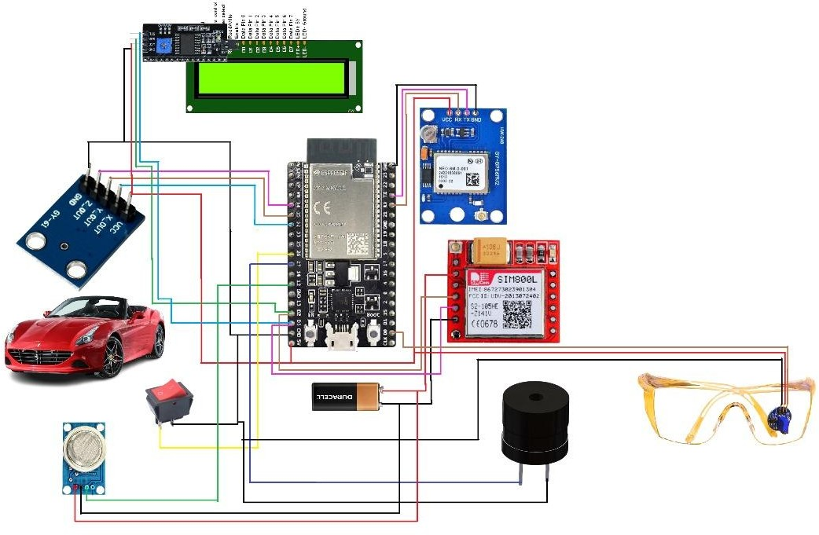

### Fig 3.5 hardware layout Design

**ESP32** : is utilized to manage a variety of sensors and carry out the required calculations.

**GPS Module:** Used to track the vehicle's location.

**GSM Module:** Facilitates communication, possibly for the purpose of sending messages or notifications.

**Accelerometer:** This device is helpful for accident detection systems because it can detect direction and motion.

**LCD Display:** Shows data, such as speed, position, or alarms.

**Buzzer**: Offers sound notifications, helpful for anti-sleep or accident warning systems.

**MQ-3 Gas Sensor:** This device measures the amount of alcohol in the air and can be used to identify intoxication or tiredness.

**Switch/Button:** Enables system control or manual input.

**Battery:** Gives the setup power.

**Glasses with a Sensor(eye Blink Sensor)** : By observing blinking patterns, these glasses may be able to identify if a driver is attentive or sleepy.

## Implementation plan/methodology

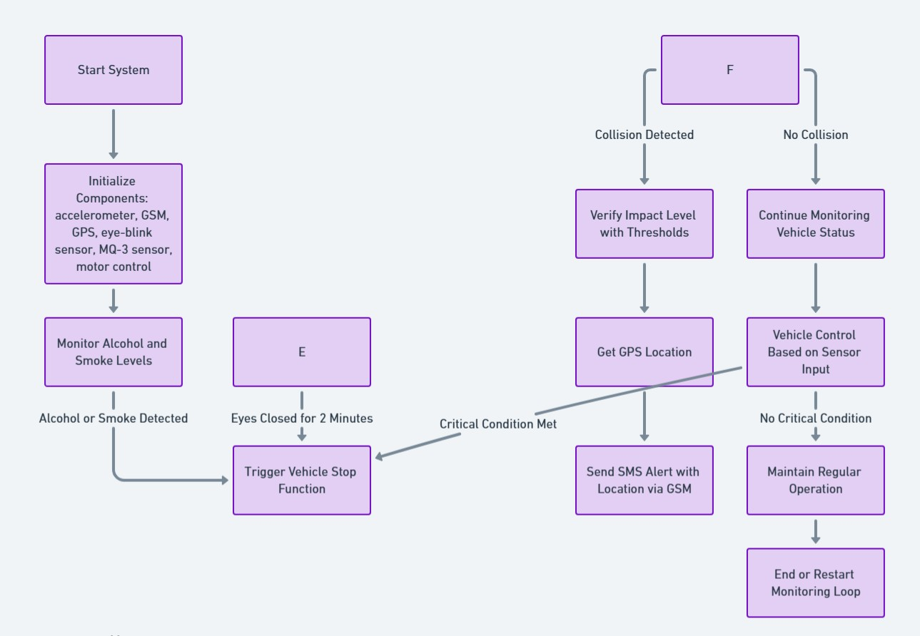

### Fig 3.6.1 Sketch Implementation

**Start :**

Set up the following sensors and modules: motor control, eye-blink sensor, MQ-3 (alcohol/smoke), accelerometer, GSM, and GPS.

### Monitor Alcohol and Smoke Levels:

* The MQ-3 sensor can identify smoke or alcohol.
* Stop the vehicle if it is detected; if not, move on to the next phase.

### Monitor Driver’s Drowsiness (Anti-Sleep Detection)

* The eye-blink sensor measures how long the eyes close.
* Stop the vehicle if your eyes have been closed for two minutes; if not, continue**. Monitor for Collision (Accelerometer Detection)**
* An accelerometer can identify abrupt impacts or changes in acceleration that point to a collision.
* If a collision happens, confirm the impact, use GPS to locate the scene, and notify emergency contacts by SMS of the location.

### Sensor-Input-Based Vehicle Control

* Stop the car for safety if a critical condition (alcohol/smoke, fatigue, collision) is identified.
* Otherwise, continue with business as usual.

### End

Reset or continuously monitor the system in response to sensor inputs.

### Block Diagram:

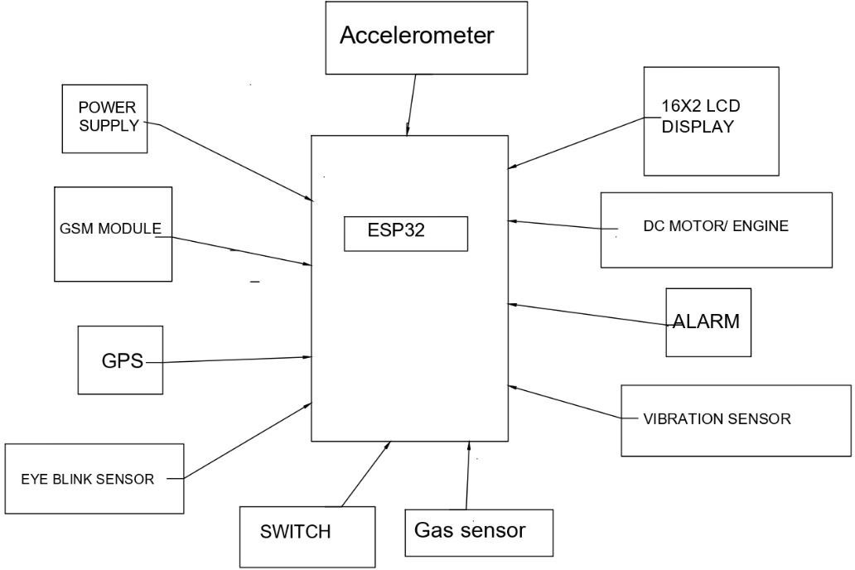

**Fig 3.6.2 Block Diagram of design**

# CHAPTER 4.

**RESULTS ANALYSIS AND VALIDATION**

## 4.1. Implementation of solution

### Analysis ;

**System requirements:** Examine the integration of the required parts (accelerometer, GPS, GSM module, MQ-3 sensor, and eye-blink sensor) in order to achieve the vehicle safety objectives.

**Sensor Selection:** Assess how well sensors such as eye-blink sensors for sleepiness detection, MQ-3 for alcohol/smoke detection, and accelerometers for collision detection function in different environmental settings.

**Data Flow:** Establish how real-time processing of data from various sensors will result in alerts and vehicle control.

**Power Consumption:** Determine how much power is needed for ongoing sensor monitoring and the function of the GSM module in SMS notifications.

### Output:

**Fig 4.1. Notification system**

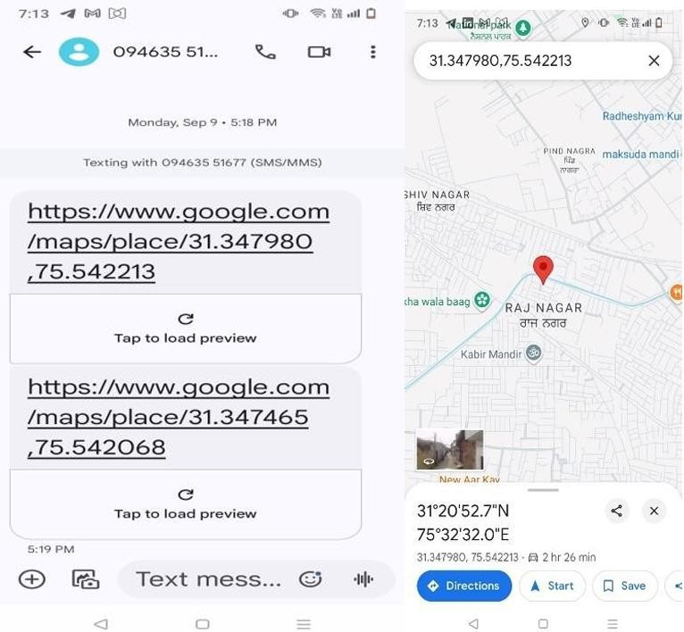

### Fig 4.2 Location Update alert

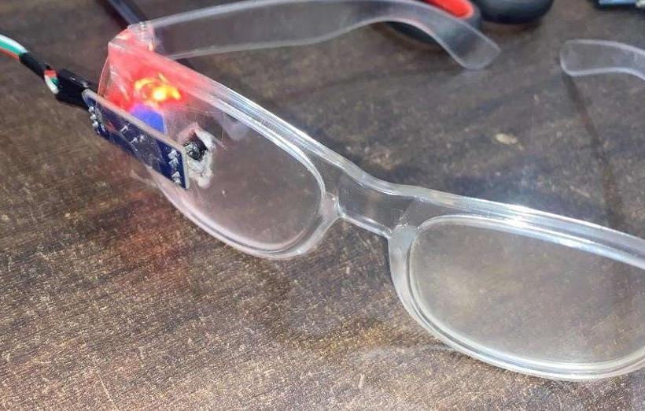

**Fig 4.3 Anti sleep alarm with Alcohol detection:**

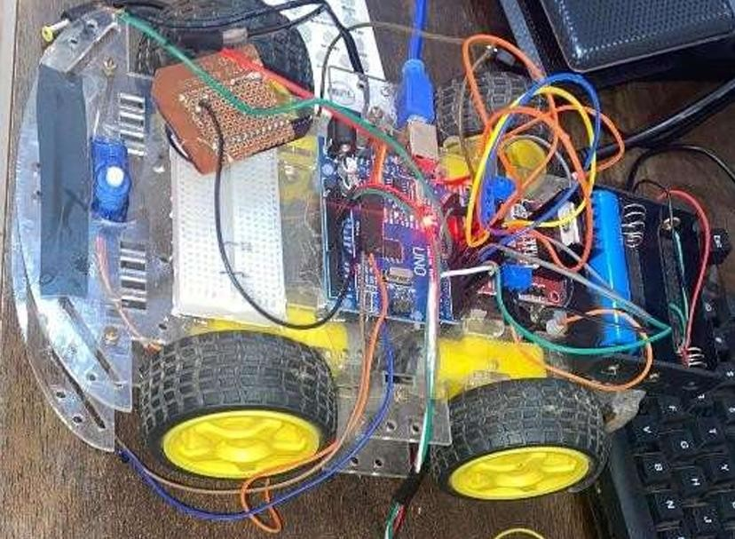

**Fig 4.4.final product**

# CHAPTER 5.

**CONCLUSION AND FUTURE WORK**

## Conclusion

Using the ESP32 microcontroller to create an Internet of Things-based car accident detection and tracking system has shown to be a workable and efficient way to improve road safety. This technology may greatly speed up response times and enhance results after auto accidents by providing real-time accident detection, position tracking, and instant alarm notifications.

This system efficiently detects collisions based on impact and abrupt deceleration thresholds by utilising the ESP32's computing power and incorporating sensors like as accelerometers, gyroscopes, and GPS modules. The chosen edge-based design is a flexible solution that can be used in both urban and rural settings, enabling accident detection and basic alerting even in places with poor connectivity. Furthermore, addressing real-world connectivity issues and boosting system resilience, employing a GPRS/SMS module for alert transmission guarantees dependable emergency notifications without continuous internet access.

### Key Benefits:

**Real-Time Response:** The system's capacity to identify and notify emergency contacts in real- time contributes to a reduction in accident response times.

**Power Efficiency:** The ESP32's local data processing reduces power usage, which is essential for automotive applications.

**Cost-Effective Implementation:** It is a cost-effective solution appropriate for fleet deployment and individual car use due to its selective cloud dependency and ESP32 usage.

**Limitations and Upcoming Enhancements:** Although the system does a good job of detecting and warning about accidents, its capacity to do sophisticated analytics and ongoing data monitoring is constrained by its edge-based methodology. In the future, combining real-time cloud analytics with machine learning (ML) models may improve detection precision and lower false positives. Additionally, more continuous data streaming would be made possible by advancements in connectivity choices like 4G and 5G, allowing for a more thorough examination of accident trends and driver behaviour.

To sum up, this IoT-based accident tracking and detection system shows promise in using IoT

technology to increase traffic safety. The technology is an affordable, flexible solution that can significantly improve the safety of both private and commercial vehicles.

## Future work

A number of possible enhancements and future research avenues could be investigated in order to increase the efficacy, precision, and functionality of the Internet of Things-based automobile accident detection and tracking system:

### Combining Machine Learning to Improve Accident Identification:

Use a machine learning (ML) model to better distinguish between real accidents and harsh braking or sharp turns, either in the cloud or on the edge (ESP32).To increase detection accuracy and lower false positives, train the algorithm using past accident data.For more flexible accident detection, use dynamic thresholds based on contextual variables like vehicle speed, road type, and weather.

### Advanced Options for Connectivity and Communication:

**4G/5G Connectivity:** In regions with dependable connectivity, upgrade the communication module to accommodate 4G or 5G for increased data throughput, real-time tracking, and cloud integration.

**Mesh Networking:** Improve response coordination in remote places by implementing a mesh network capability that allows cars to send alerts to one another in areas without cellular coverage.

### Connectivity with Traffic Management Systems and Emergency Services:

To expedite notifications and give dispatchers access to real-time accident data, establish direct connections with nearby emergency services.

To enable automatic road clearing, accident reporting, and dynamic rerouting around accident areas, integrate the system with traffic control platforms.

### Extended Reporting and Analytics for Data:

Give fleet managers access to comprehensive data logging and analysis on cloud servers so they can track driving trends, pinpoint areas that are prone to accidents, and put safety measures in place.Make personalised dashboards for fleet managers and users that show repair requirements, driving behaviour, and accident history, offering insightful information to increase fleet safety.

### Improved Mobile App and User Interface:

Provide a specialised web interface or mobile app that allows fleet operators and car owners to

examine travel history, accident notifications, and real-time location data.Incorporate user-driven features like adding emergency contacts straight from the app, customising alert options, and reporting a false positive.

### Enhanced Detection Potential with Extra Sensors:

Add more sensors, like gas and temperature sensors, to identify any car fires or dangerous gas leaks after an accident.Utilise camera modules for image recognition so that the system can visually verify mishaps and provide responders with more scene information.

### Optimising Batteries and Integrating Solar Power:

To increase battery life, investigate cutting-edge power management strategies including effective wake-up schedules and adaptable deep sleep modes. Include a tiny solar panel for self-sufficient operation; this is especially helpful for fleet vehicle deployments in remote locations or for extended use.

### Monitoring of Vehicle Health:

Incorporate an On-Board Diagnostics (OBD-II) module to track factors like engine temperature, fuel levels, and other diagnostic data and to keep an eye on the vehicle's overall health. Predict car problems (such brake failure) that could cause collisions, allowing for preventative repair and lowering the chance of an accident.

### Route tracking and geofencing for fleet management:

Use geofencing features to notify fleet management when a car leaves a designated zone or path. Fleet managers can adjust routes for safer travel by tracking and analysing route data to identify high-risk or accident-prone locations.

### Support for larger deployments and scalability:

Improve cloud infrastructure to accommodate extensive deployments, like commercial vehicle tracking systems or entire fleets.To efficiently handle numerous vehicles' alerts at once, implement bulk alert management and reporting systems.

# REFERENCES

[1]. T kalyani, S Monika, B Naresh, Mahendra Vucha “Accident Detection & Alert System “

IJITEE ISSN:2278-3075,Vol-8 Issue-4S2 March 2019

[2]. Irstam Ghazi, Muhammad Rashid Maqbool, Ihtisham ul Haq, Sananaam Saud “ GPS Based Autonomous Vehicle Navigation and Control System” CoiNet Technology solutions LLP, LPC2148 ARTIST Instruction manual Digital.csic.es/bitstream/10261/127788/7/D-C-

%20Arduino%20uno ESP8266 802.11bgn Smart Device/Express if systems/October 2013

[3]. Manjunath Kamath K, et al. “Automatic Accident Detection and Alerting System Based on IOT”, International Journal of Innovative Research in Computer and Communication Engineering,

Vol. 5, Issue 5, May 2017

[4]. Sikander, Gulbadan, and Shahzad Anwar. "Driver fatigue detection systems: A review." IEEE Transactions on Intelligent Transportation Systems 2018; 20 (6): 2339-2352.

[5]. ubbarao, A., and K. Sahithya. “Driver drowsiness detection system for vehicle safety.” Int. J. Innov. Technol. Explor. Eng 8 (2019): 815-819.

[6]. Ueno, Hiroshi, Masayuki Kaneda, and Masataka Tsukino. "Development of drowsiness detection system." In Proceedings of VNIS'94-1994 Vehicle Navigation and Information Systems Conference. 31 August 1994-02 September 1994; Yokohama, Japan. US: IEEE, 1994. pp. 15-20.

[7]. Xing, Tianzhang, Qing Wang, Chase Q. Wu, Wei Xi, and Xiaojiang Chen. "Dwatch: A reliable and low-power drowsiness detection system for drivers based on mobile devices." ACM Transactions on Sensor Networks (TOSN) 16, no. 4 (2020): 1-22.

[8]. Biswal, Anil Kumar, Debabrata Singh, Binod Kumar Pattanayak, Debabrata Samanta, and Ming-Hour Yang. "IoT-based smart alert system for drowsy driver detection." Wireless communications and mobile computing 2021 (2021)

# APPENDIX

### Plagiarism Report

1. **Design Checklist**

# USER MANUAL

(Complete step by step instructions along with pictures necessary to run the project)